Text Selection Guidance Resource: Rich Literature


Acknowledgement
The Victorian Curriculum and Assessment Authority proudly acknowledges and pays respect to Victoria’s Aboriginal and Torres Strait Islander communities and their rich and enduring cultures.
We acknowledge Aboriginal and Torres Strait Islander people as Australia’s first peoples and as the Traditional Owners and custodians of the lands and waters on which we rely. We pay respect to Elders past and present of the lands where we conduct our work and recognise their ongoing contributions as the first educators on the land now known as Victoria.
Authorised and published by the Victorian Curriculum and Assessment Authority
Level 7, 200 Victoria Parade
East Melbourne VIC 3002
© Victorian Curriculum and Assessment Authority 2025
No part of this publication may be reproduced except as specified under the Copyright Act 1968 or by permission from the VCAA. Excepting third-party elements, schools may use this resource in accordance with the VCAA educational allowance. For more information go to vcaa.vic.edu.au/footer/copyright.
The VCAA provides the only official, up-to-date versions of VCAA publications. Details of updates can be found on the VCAA website at vcaa.vic.edu.au.
This publication may contain copyright material belonging to a third party. If you believe that material in this publication is an infringement of your copyright, please email the Copyright Officer at vcaa.copyright@education.vic.gov.au.
Copyright in materials appearing at any sites linked to this document rests with the copyright owner/s of those materials, and is subject to the Copyright Act. The VCAA recommends you refer to copyright statements at linked sites before using such materials.
The VCAA logo is a registered trademark of the Victorian Curriculum and Assessment Authority.

Contact us if you need this information in an accessible format, for example large print or audio.
Telephone (03) 9032 1629 or email vcaa.publications@education.vic.gov.au.

Contents
Introduction 1
Text selection 1
Text complexity 2
Text complexity levels 2
Elements that influence text complexity 2
Additional considerations in text selection 3
Purpose 3
Representation 4
Perspective 4
Knowledge 4
Cross-curriculum priorities 4
Modelled text appraisal 5
Summary 13
Appendix 14
Text complexity levels mapped to other measures 14
Lexile 14
Lexile stretch bands 15
Flesch–Kincaid 16
Example text lists 16
References 16

Introduction
Text Selection Guidance Resource: Rich Literature has been developed to support teachers teaching the Victorian Curriculum F–10 Version 2.0 English (English Version 2.0). This resource outlines and gives examples of the relevant factors that contribute to the text selection process for rich literature. It is complemented by Text Selection Guidance Resource: Decodables.

Text selection
Text selection is a complex component of planning for teaching and learning because there are many different elements of reading to teach and many purposes for reading. Teachers are often tasked with selecting simple, authentic texts to support emergent readers with decoding practice and fluency development at one point in the day, while needing to then select richer, more challenging texts (rich literature) to build vocabulary, oral language and comprehension at another point in the day.
Decodable texts | Simple and elementary authentic texts | Rich literature
These are phonetically controlled texts designed to support decoding and fluency practice for emergent readers. They may support the development of vocabulary, language and knowledge, although this is not their primary aim.  These are typically texts for students to read aloud to a peer, parent/carer, teacher or education support staff member. | These are natural language texts typically written with simple vocabulary and sentence structure. They are designed to develop word recognition, fluency and comprehension practice in emergent readers.  The overall level of difficulty is comparable to decodable texts. The distinction is that authentic texts are not phonetically controlled.  These are typically texts for students to read aloud to a peer, parent/carer, teacher or education support staff member. | These are moderately complex and complex authentic and literary texts. They support the development of vocabulary, language, content knowledge, literary/text knowledge and reading comprehension.  These are typically texts for teachers to read aloud to students at Foundation and Level 1.
This resource will focus on selecting rich literature for classrooms. For guidance on selecting decodable texts to support early or emerging readers, see the Text Selection Guidance webpage and download Text Selection Guidance Resource: Decodables. ‘Rich literature’ is a term used to describe texts that are highly regarded because of the quality of knowledge, language, vocabulary and perspectives they contain, and their capacity to challenge, broaden and enrich students’ thinking and learning. Rich literature includes authentic and literary texts. For further detail, see the glossary.
Teachers should consider all strands of the English curriculum when assessing a variety of rich and challenging texts across curriculum levels. Text selection should be based on the purpose of the teaching and learning unit, with consideration for where students are at on the novice to expert reader continuum.
In Foundation and Level 1, the English curriculum focuses on building knowledge and skills in the Literacy strand (Phonic and word knowledge and Building fluency and making meaning sub-strands). This is achieved with simpler texts to develop reading as an independent skill and rich literature (as indicated in the Language and Literature strands) to build vocabulary, understanding of text structures and features, and ideas. These experiences in the early years allow access to more complex texts as students move through curriculum levels.
While students are practising their early reading skills using simpler texts in Foundation and Level 1, a significant amount of time will also be spent on reading and exploring rich literature. It is important that while students develop basic reading proficiency, they are also exposed to rich and complex texts. Teachers should also consider this as they plan for learning.
From Level 2, once the basics in decoding and word recognition have been secured, texts selected to support guided and independent practice in the Phonic and word knowledge and Building fluency and making meaning sub-strands (Literacy stand) naturally increase in complexity. At the same time, texts selected to engage and develop the skills located in the Language and Literature strands will also increase in complexity year on year, and students will engage with these texts via a combination of teacher read-aloud (or author narration for audio texts and teacher narration for visual texts) and a gradual release to more independent reading with frequent pause points for discussion and strategy application.
When appraising texts for selection, teachers should consider a range of factors, including overall text complexity, purpose, representation, perspective, knowledge-building opportunities and cross-curriculum priorities.

Text complexity
Text complexity refers to the overall readability or challenge of a text. In English Version 2.0, content related to the level of text complexity is located across the sub-strands of Text structure and organisation, Language for expressing and developing ideas, Literature and contexts, Engaging with and responding to literature, Examining literature, Texts in context and Analysing, interpreting and evaluating.
The key aspects of text complexity are further highlighted in the appendix (p. 44) of the Literacy Foundational Skill, which includes descriptions of each level of text. Students are expected to read and be exposed to increasingly complex fiction and non-fiction texts as they progress through their schooling.

Text complexity levels
Simple
Elementary
Moderately complex
Complex
Highly complex

Elements that influence text complexity
Text complexity includes quantitative and qualitative elements. Quantitative measures are an overall estimation of complexity based on vocabulary and on sentence length and complexity. Qualitative elements (Chall et al. 1996; Spencer et al. 2018) are typically categorised as:
language structures (e.g. sentence types/forms, conventions, literal/figurative, contemporary/archaic)
text structure (e.g. print and layout features, conventional/unconventional, genre/discipline structures)
content (e.g. vocabulary, topic knowledge, general knowledge)
meaning (e.g. obvious/hidden, single/multiple).
See the Appendix for further detail.

Additional considerations in text selection
Additional considerations in rich literature text selection include purpose, representation, perspective and knowledge, as shown in the following figure.
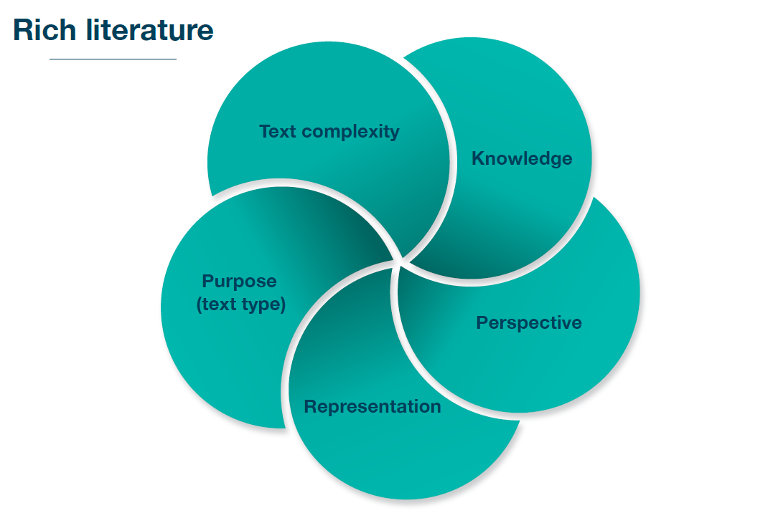

Purpose
What type of text is this?
Why was it written?
What are its features?
This is a chance to consider different types of texts, including a variety of purposes and features. The English curriculum requires all students to engage with narrative, persuasive and informative texts as well as poetry.

Representation
Who is included?
What is the setting?
What are the power structures?
This will allow consideration of the breadth and depth of settings and place (including historical), of relationships and tensions and of social and cultural contexts. Over time, texts should offer diverse representations for students to engage with.

Perspective
Who speaks?
Whose stories are told?
This is an opportunity for students to hear the voices of different individuals. Consideration should be given to gender, race, age, ability and diverse geographic settings (e.g. rural and metropolitan). Historical and contemporary voices can also be considered.

Knowledge
What topics are covered?
Are there connections to other learning areas?
What new knowledge will students experience through reading this text?
This can give opportunities to build world knowledge, literary/cultural knowledge or domain/topic/content knowledge, and to address historical and contemporary issues, challenging ideas, local/global perspectives, diverse representations or cross-curriculum priorities/connections.
Given that complex and highly complex texts are often introduced from Level 4, appraising texts for additional language, vocabulary, knowledge and perspective learning opportunities, as well as more nuanced ideas and mature themes (e.g. contested ideas or controversial historical periods), becomes even more important to ensure suitable comprehension challenges for students.

Cross-curriculum priorities
The Victorian Curriculum F-10 includes cross-curriculum priorities (CCPs): Aboriginal and Torres Strait Islander Histories and Cultures, Asia and Australia’s Engagement with Asia and Sustainability. The CCPs are embedded across all learning areas in meaningful ways.
In the English curriculum, the CCPs are evident in the Literature and contexts sub-strand (Literature strand), with the depth and breadth of engagement determined by the texts selected by schools and teachers for classroom study.
When teachers are considering the elements of representation, perspective and knowledge in texts, they should also consider the organising ideas in each of the CCPs.

Modelled text appraisal
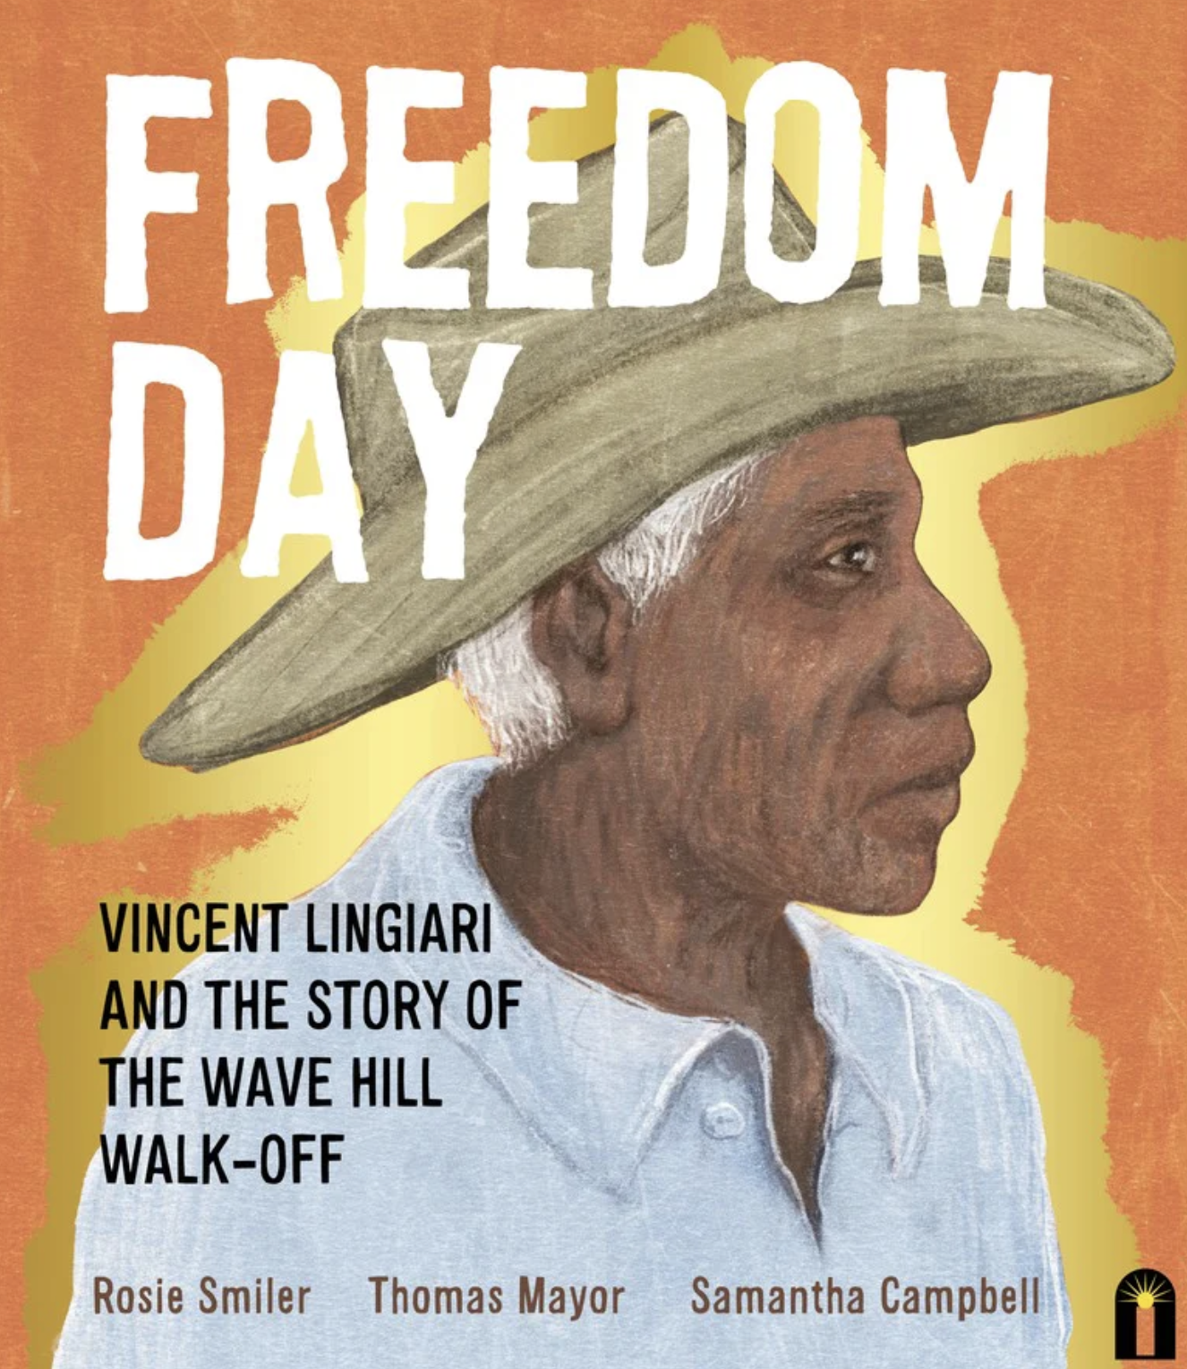
Title: Freedom Day: Vincent Lingiari and the Story of the Wave Hill Walk-Off
Authors: Thomas Mayor, Rosie Smiler and Samantha Campbell (illustrator)

Text complexity | Moderately complex (Lexile not available)  Tier 2 vocabulary and opportunity to learn Aboriginal language (abundance, bountiful, ambushed, meagre, legacy, vibrant, intimidated, dignified, harsh, cherish, kartiya, karu, murnnunku)  Some complex sentence structure and phrasing, which provides an opportunity for rich discussion and making connections
Knowledge | Significant opportunities to build knowledge (Vincent Lingiari, Wave Hill Cattle Station, Wave Hill Walk-Off, Gurindji people, Northern Territory, Gough Whitlam, slave labour, wages and conditions, contemporary Australian history, colonisation, land ownership, native title, protest, Uluru Statement from the Heart, The Voice)
Perspective | Opportunities to hear the voices of individuals with direct connection to these events in history (one author is Vincent Lingiari’s granddaughter)
Representation | Diversity of representation, Aboriginal and Torres Strait Islander storytelling, exploration of power structures and righting wrongs/standing up to injustice and discrimination
Purpose/text type | Exposure to narrative non-fiction
CCP | Aboriginal and Torres Strait Islander Histories and Culture

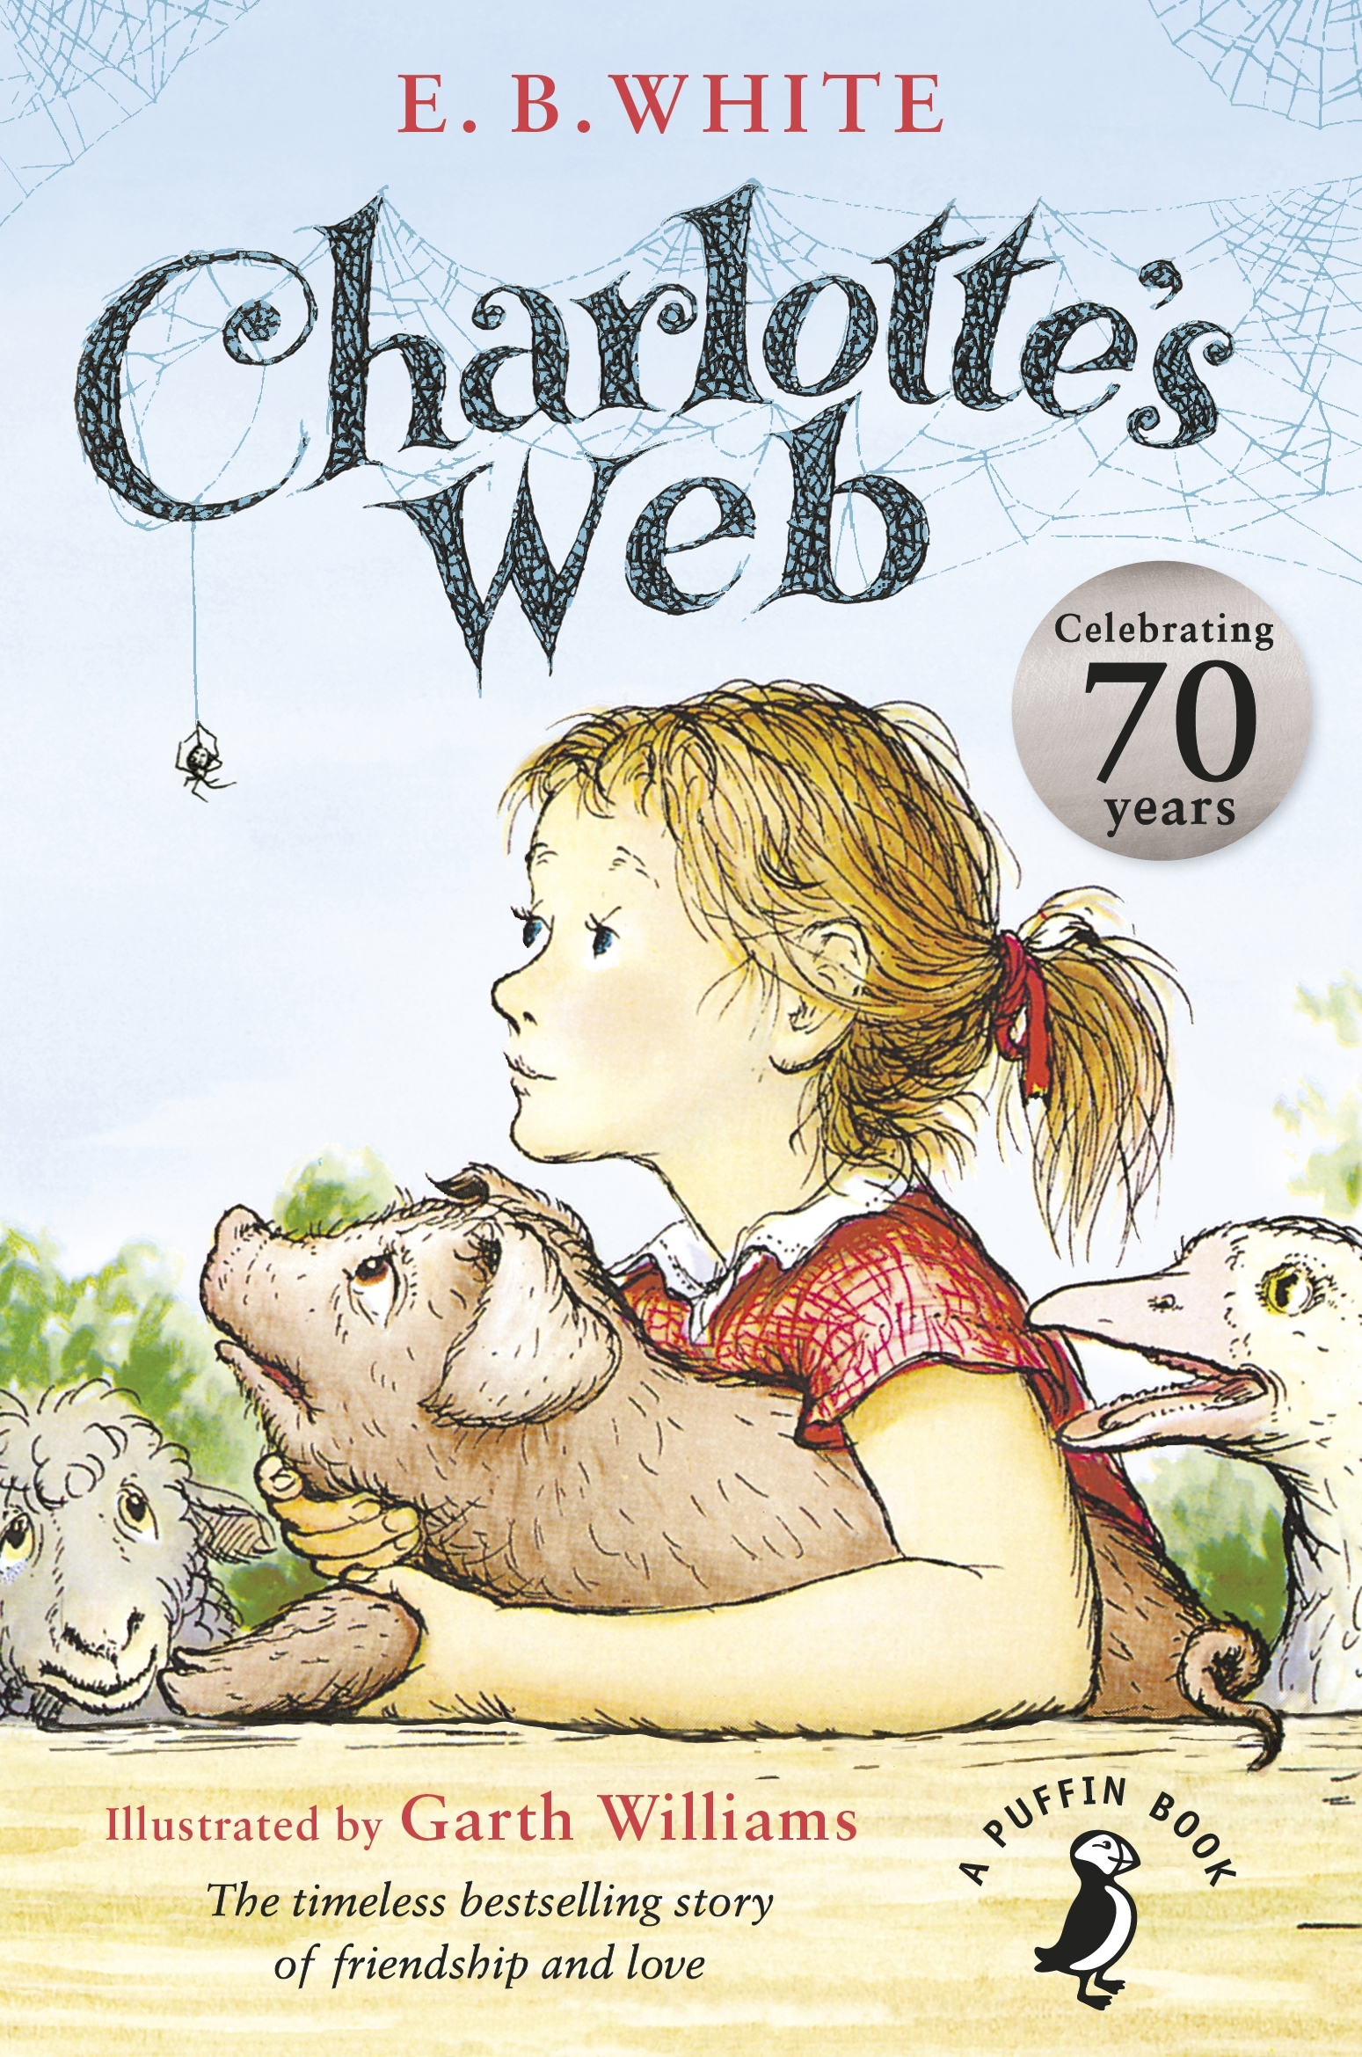
From Charlotte’s Web by E. B. White published by Puffin Books. Copyright © E. B. White 1952. Reprinted by permission of Penguin Books Ltd.
Title: Charlotte’s Web
Author: E. B. White
Level: 3
Text complexity | Moderately complex (680L)  Tier 2 vocabulary (untimely, blissful, gaze, rapidly, bitterly, gloomily)  Complex sentences and archaic language to explore  Structure allows for a range of narrative focus points (characterisation, settings, themes, events, mood)  Print/layout features: some illustrations to support transition to predominantly print-only texts
Knowledge | Content knowledge: American history and geography, farming and farming practices, animals, gender roles and family, lifestyle, money, anthropomorphism, human/animal relationships, language changes over time  Literary knowledge: rich and complex themes including belonging, compassion, connection, friendship, morals, mortality, persistence, language techniques
Perspective | Diversity of voice between adult/child and human/animal  No central diversity perspectives covered, affirming the perspectives of the time
Representation | Female protagonist, power struggle between parents and child, the roles of girls and women  No significant diversity of representation
Purpose/text type | Narrative, archaic text/literacy classic, coming of age, quest
CCP | Sustainability

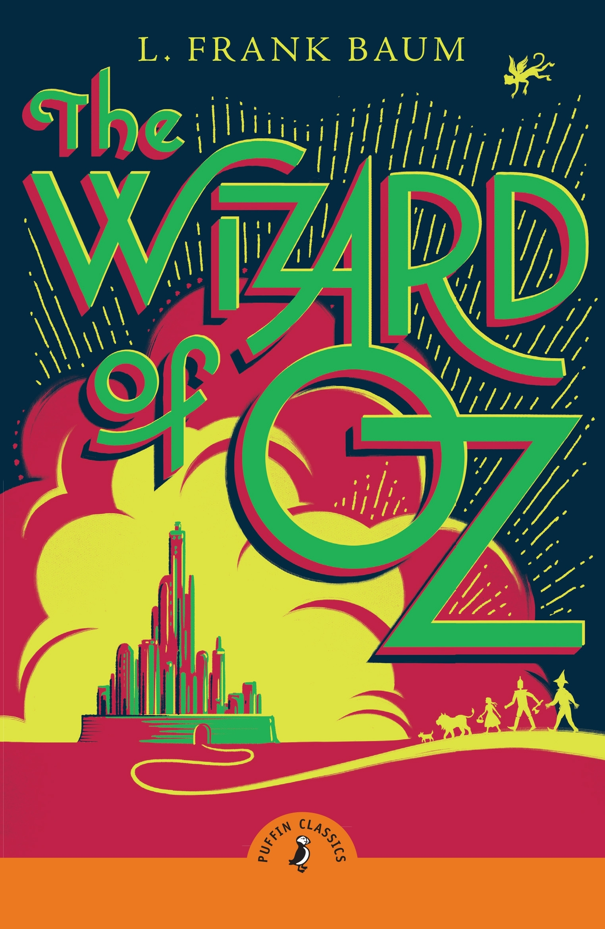
From The Wizard of Oz by L. Frank Baum published by Puffin Books. Copyright © L. Frank Baum 1900. Reprinted by permission of Penguin Books Ltd.
Title: The Wizard of Oz
Authors: L. Frank Baum
Levels: 4 and 5
Text complexity | Highly complex (1030L)  Tier 2 vocabulary (earnestly, splendid, fulfilment)  Complex sentence structures, sometimes with archaic form to explore/teach
Knowledge | Content knowledge: Kansas, tornado, American history/culture and geography  Literary knowledge: non-literal language, symbolism, plot, characterisation, pun
Perspective | No particular diversity of perspective outside the diversity of characters, affirming the perspectives of the time
Representation | Female protagonist, power struggles, wrestling with right and wrong, wrestling with internal versus external validation
Purpose/text type | Fantasy, narrative, adventure, archaic text/literacy classic
CCP | No CCP links, but several opportunities to link this text to other learning areas

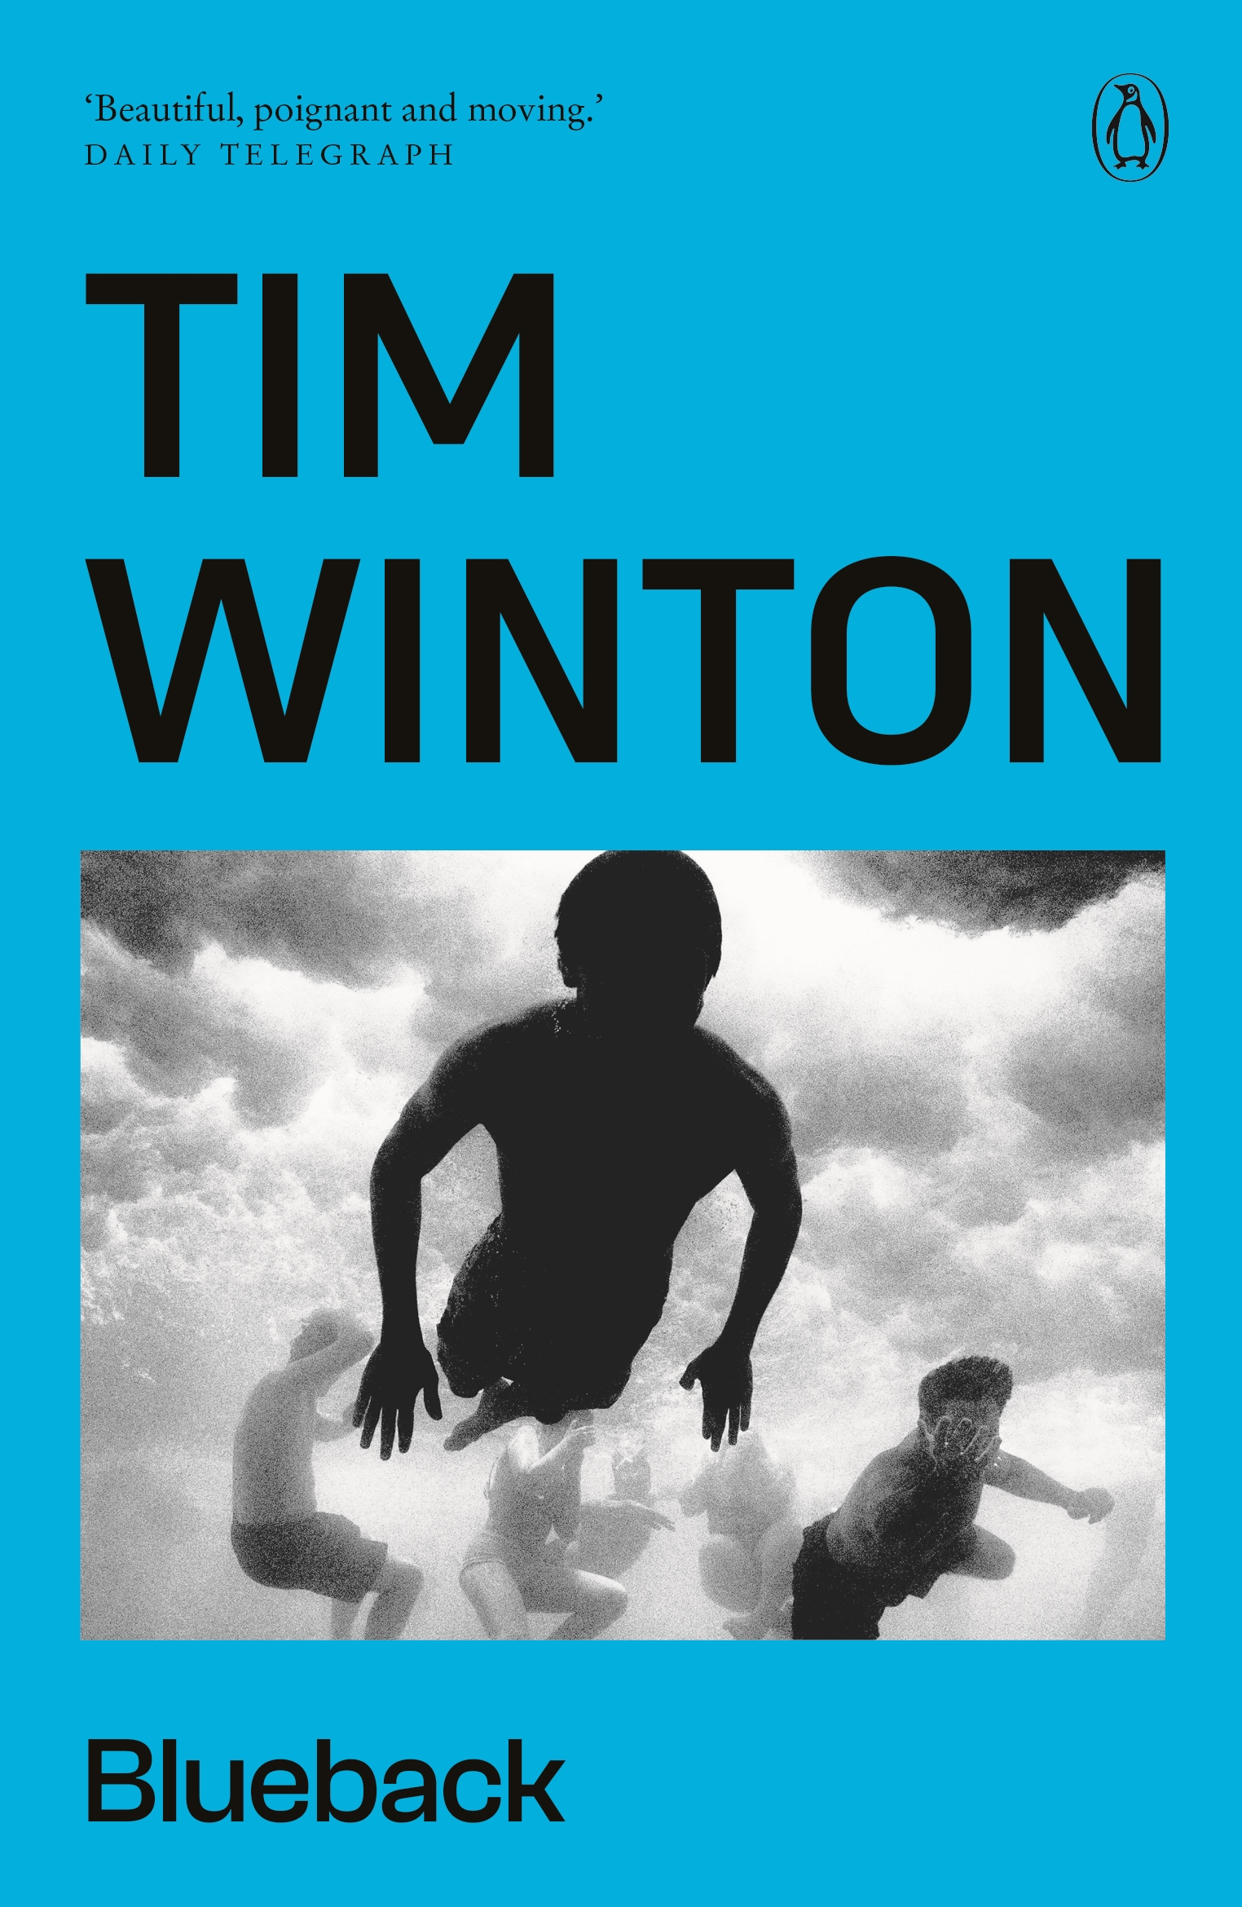
Used by arrangement with Penguin Random House Australia Pty Ltd. Cover design by Design by Committee © Penguin Random House Australia Pty Ltd. Cover image courtesy Trent Parke / Snapper Media.
Title: Blueback
Authors: Tim Winton
Level: 5
Text complexity | Highly complex (780L)  Tier 2 vocabulary (prickled, flitted, certainly, terribly, thudding, tormented, buckled)
Knowledge | Content knowledge: impact of development and fishing on the ocean and ocean life, sustainability, protecting the environment/conservation, nature, coasts, bays, Western Australia coastline, human greed, change over time, technical vocabulary (e.g. boating and fishing terms)  Literary knowledge: figurative language, symbolic language
Perspective | No significant diversity of perspective
Representation | Power imbalance between child/adult, developers/locals, wealthy/protectors of the environment
Purpose/text type | Narrative, allegory/fable style
CCP | Sustainability

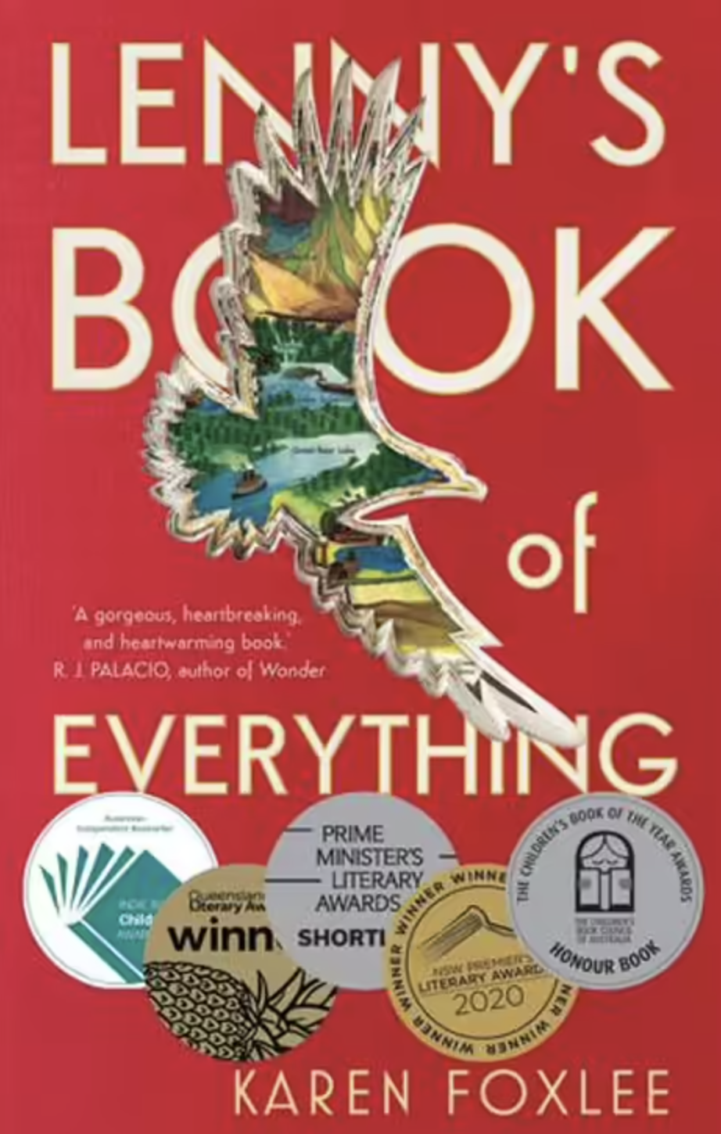
Title: Lenny’s Book of Everything
Authors: Karen Foxlee
Levels: 7 and 8
Text complexity | Highly complex (Lexile not available, secondary school level)  Tier 2 vocabulary (sprang, flicker, fidgety, gloom, trinity, furiously, scrambled)  Print/layout features: novel with chapters labelled with height, date and letters/other text types embedded within the text; encyclopedia format to follow
Knowledge | Content knowledge: rich opportunities to build knowledge via the encyclopedia format (weekly delivery of Burrell’s Build-It at Home Encyclopedia)  Literary knowledge: symbolism
Perspective | Gigantism, illness, affirming perspectives
Representation | Difference of size/ability, difference in life opportunity (real versus imagined life)
Purpose/text type | Fiction, child perspective/narration, coming of age, encyclopedia format
CCP | No CCP links, but several opportunities to link this text to other learning areas

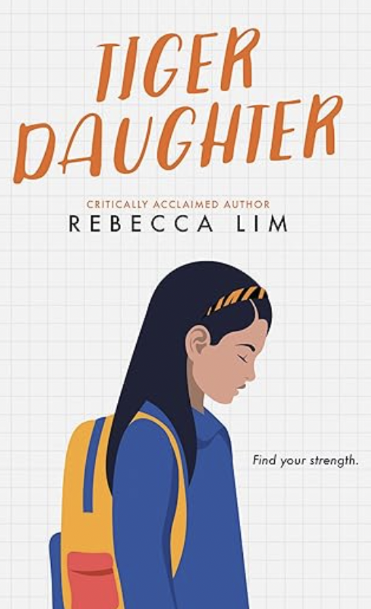
Title: Tiger Daughter
Authors: Rebecca Lim
Levels: 7 and 8
Text complexity | Highly complex (980L)  Tier 2 vocabulary (incomprehensible, immaculate, apprehensive, precise, discreet, pedestrian, mythical, nourishment, glistening)  Complex narrative structure
Knowledge | Chinese culture and values, immigration, common parent expectations when moving to a new country
Perspective | Representation of adult and child migrant views, diversity of voice, young female protagonist, cross-cultural perspectives and values, first-generation migrant school experience
Representation | Adult and child power, relationship tensions, coming of age and individuation as a first-generation migrant, cultural diversity, emotional depth and breadth (hope versus heartbreak)
Purpose/text type | Fiction, child perspective/narration, coming of age
CCP | Asia and Australia’s Engagement with Asia

Summary
Text selection is a complex component of planning for teaching and learning. In this resource, guidance has been provided to support teachers in the process of text selection by outlining and providing examples of the relevant factors that contribute to the text selection process for rich literature. For further support, see Text Selection Guidance Resource: Decodables.

Appendix

Text complexity levels mapped to other measures
There are several quantitative (readability) measures of text complexity. There is no gold standard measure, although some are more useful or reliable than others. All measures have their limitations, so quantitative dimensions should always be considered alongside qualitative dimensions as detailed earlier.
Texts were once categorised as simple, predictable, moderately complex and sophisticated, then updated to simple, predictable, moderately complex, complex and highly complex. Texts are now categorised as simple (includes decodable texts), elementary (includes decodable texts), moderately complex, complex and highly complex. While care has been taken to describe the features of each text category in detail in the Literacy Foundational Skill, teachers are still required to appraise and cross-check features of individual texts.

Lexile
Often called the Lexile Framework for Reading or Lexile reader measures, the Lexile is an overall measure of text complexity calculated after appraising vocabulary and sentence length (MetaMetrics 2018). The Lexile scale includes the initial Beginning Reader Lexile ranges (BR300L, BR200L and BR100L) through to beginning standard reader Lexiles with a range of 0 to 2000L. The higher the Lexile, the more complex the text (MetaMetrics 2018).
Lexiles were originally assigned to texts, but over time it became the process to assign Lexiles to students via various forms of ‘levelling’ assessment. For many years now, students have been matched to a text level (via a levelling assessment) and grouped for reading instruction that way for most of their reading instruction in the primary years. With matched texts, students are usually expected to have relatively good comprehension, at around 75%.
Reading experts more recently have criticised the idea of assigning Lexiles to individual students for a range of reasons, including the following.
Texts may not be challenging enough. Teachers want to stretch students beyond what they can do relatively well themselves (i.e. zone of proximal development).
When students are grouped for levelled instruction, there is less time with the teacher and less time spent checking their comprehension/progress.
Not getting to read/enjoy the same texts or enjoy grade-level material may be an equity issue for students in the same class.
Grouping for levelled instruction limits whole-class shared text experiences.
There is a risk some students will not reach grade-level expectations over the course of primary school.
Teachers want text selection and associated instruction to accelerate growth for all students.

Lexile stretch bands
Lexile ‘stretch’ bands are Lexile ranges that were set to guide whole-class text selection or the setting of grade-level expectations (Common Core State Standards 2012; The Aspen Institute 2012). After finding students experienced relatively low comprehension growth year on year, and/or that students were not finishing high school ready for college in terms of reading comprehension (American College Testing 2010), more ambitious grade-level expectations now guide text selection rather than assigning levels to individual students and grouping those students for instruction. The central ideas are that:
teachers should set challenging grade-level expectations year on year and support all students to rise to the comprehension challenge
texts quantitively increase in complexity with every year of schooling so students read harder and harder texts
primary texts prepare students for secondary texts
secondary texts prepare students for work, life and/or tertiary study (Adams 2011, Cabell 2024).
The structural difference here when setting grade-level expectations is that comprehension should likely be taught predominantly via whole-class instruction with differentiated support rather than via small-group levelled instruction (which would be below grade level for some or many students) with differentiated texts.
While the stretch bands do not vary too significantly from the original Lexile reader measures, the differences are important. You will note in the table below that each primary year level starts at a much higher Lexile in the stretch bands, and the stretch bands are intended for setting whole-grade expectations and whole-class reading. The Lexile reader measures also set grade-level expectations, but standard practice has been that individual student or small-group texts are selected based on assigned Lexile levels rather than grade-level expectations, and in this model many students will spend a lot of time reading texts below grade level.
Grade | ‘Stretch’ Lexile band | Lexile reader measures
1 | 190–530L | BR120L–295L
2 | 420–650L | 170–545L
3 | 520–820L | 415–760L
4 | 740–940L | 635–950L
5 | 830–1010L | 770–1080L
6 | 925–1070L | 855–1165L
7 | 970–1120L | 925–1235L
8 | 1010–1185L | 985–1295L
9 | 1050–1260L | 1040–1350L
10 | 1080–1335L | 1085–1400L
11 and 12 | 1185–1385L | 1130–1440L
This table is based on Lexile Framework for Reading: Educator Guide (MetaMetrics 2018).
As discussed when reviewing the Lexile Framework for Reading, while the concepts of assigning levels of difficulty to texts and students progressing through levels (reading harder and harder books) have merit, assessing to assign levels to students and then grouping for instruction comes with several risks. These include students rarely sharing whole-class text experiences and some students never getting to experience grade-level texts.

Flesch–Kincaid
There are 2 Flesch–Kincaid readability measures: reading ease and grade level. Reading ease is calculated using a formula based on word length and sentence length. The higher the readability, the easier the text. The lower the readability, the more complex the text. Reading ease is useful from Grade 5 onwards. Grade level is also calculated based on word and sentence length, but the formula differs significantly to generate a grade-level estimate for a text (Readable 2024).

Example text lists
Dyslexia-SPELD Foundation – Australian Reading Spine
https://dsf.net.au/CMSPages/GetFile.aspx?guid=5e928e9f-418c-4f14-b437-c9f5c98c8268
New South Wales Government – Education: Quality Literature Recommendations
https://education.nsw.gov.au/teaching-and-learning/curriculum/english/planning-programming-and-assessing-english-k-6/selecting-quality-texts/quality-literature
Ochre Education – F-10 Reading Spine
https://ochre.org.au/blog/access-the-new-ochre-education-draft-f-10-reading-spine
Copyright Agency – Reading Australia (Note: While not set out as a ‘reading spine’, the Reading Australia website lists a large range of texts, provides teacher resources for teaching those texts and includes a suggested grade/year level for teaching.)
https://readingaustralia.com.au/level/primary/?post_type=book&orderby=meta.level_override.long&order=asc

References
Adams MJ (2011) ‘Advancing our students’ language and literacy: the challenge of complex texts’. American Educator, Winter 2010–2011:3–11, accessed 26 September 2025.
American College Testing (2010) A First Look at the Common Core and College and Career Readiness, ACT Education Corp, 29 November, accessed 26 September 2025.
Cabell S (2024) Choosing and Using Complex Text, Massachusetts Department of Elementary and Secondary Education, accessed 26 September 2025.
Chall JS, Bissex GL, Conard SS and Harris-Sharples SH (1996) Qualitative Assessment of Text Difficulty: A Practical Guide for Teachers and Writers. Brookline Books.
Common Core State Standards (2012) Achieve the Core, accessed 26 September 2025.
MetaMetrics (2018) Lexile Framework for Reading: Educator Guide, accessed 26 September 2025.
Readable (2024) Flesch Reading Ease and the Flesch Kincaid Grade Level, accessed 26 September 2025.
Spencer M, Gilmour AF, Miller AC et al. (2018) ‘Understanding the influence of text complexity and question type on reading outcomes’, Reading and Writing, 32:603–37, accessed 26 September 2025.
The Aspen Institute (2012) Text Complexity and the CCSS, accessed 26 September 2025.

